**Remote Command MRD**

|  |  |  |  |
| --- | --- | --- | --- |
| **Date** | **Author** | **Version** | **Comments** |
| 2021/5/27 | 王伟 | V0.1 | 初稿 |
| 2021/6/10 | 王伟 | V0.2 | 删除激活远程控制 |

目录

1背景 1

1.1 Purpose 1

1.2 Architecture Design Reference 1

2 Requirements 2

2.1 遥控空调控制 3

2.2 方向盘加热和座椅空调 4

2.3 座椅空调 6

2.4 周期 7

3 FBMP协议简介 7

# 1背景

## Purpose

本文主要依据Remote Command需求，结合Vehicle Settings SPSS阐述Remote Command功能范围及工作流程。

## Architecture Design Reference

|  |
| --- |
| **Design Documents** |
| 1. SYNC+_Phase5_FIP V2.11_0524.xlsx |
| 1. Settings In Infotainment CenterStack SPSS v1.20 Nov 2, 2020.pdf |

# Requirements

遥控启动设置包含空调控制、方向盘加热、座椅空调、启动周期。

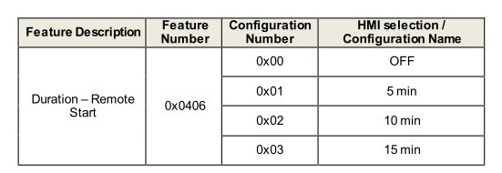

上面截图来自Settings In Infotainment CenterStack SPSS v1.20 Nov 2, 2020.pdf

根据Vehicle Settings spec中要求，HMI设计中如果有Remote Start开关项的话，Operation = 0x2 FeatureID= 0x0406

Configuration = 0x00 则表示Remote Start开关关闭；Configuration = 0x02则表示Remote Start开关打开。根据当前需求，Configuration将在下线出厂时始终配置为0x02，不再保留单独的遥控启动控制开关。

**注：FBMP协议可参见第3章FBMP协议简介**

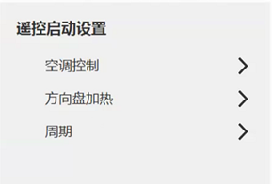

遥控启动将始终处于打开（enabled）的状态。在“激活遥控启动”被错误配成关闭（disabled）时，所有设置按键将变灰无法点击，同时下方出现用户提示文案“该功能被异常关闭，请尽快前往经销商处进行复位”。

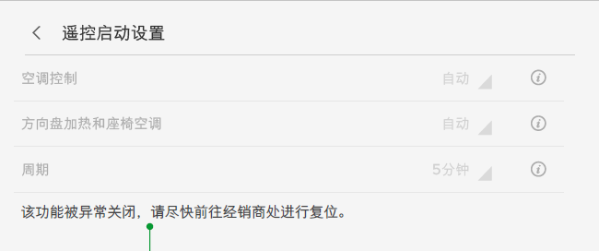

## 遥控空调控制

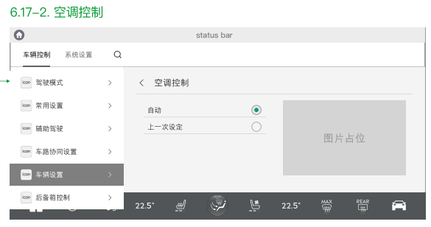

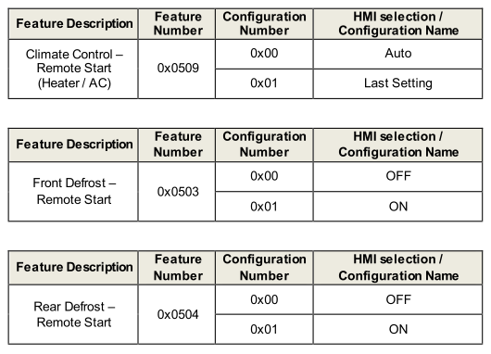

根据Vehicle Settings spec中要求：

设置空调控制为Auto时需发送如下消息

Operation = set

1. Climate Control (ID 0x509) = Auto
2. Front Defrost (ID 0x503) = ON
3. Rear Defrost (ID 0x504) = ON

三个feature配合使用才可设置成功。

设置空调控制为Last Setting时需发送如下消息

Operation = set

1. Climate Control (ID 0x509) = Last Setting
2. Front Defrost (ID 0x503) = ON
3. Rear Defrost (ID 0x504) = ON

三个feature配合使用才可设置成功。

界面接收response消息时只根据Climate Control (ID 0x509)的结果显示Auto还是Last Setting。Front Defrost (ID 0x503)和Rear Defrost (ID 0x504)的状态可忽略。

## 2.2 方向盘加热和座椅空调

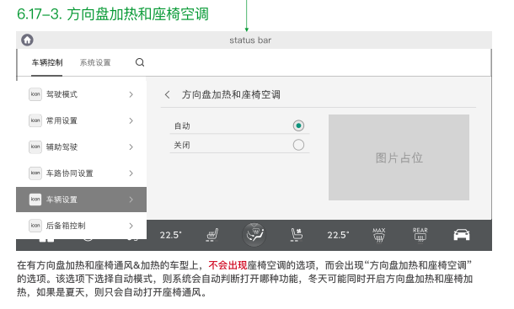

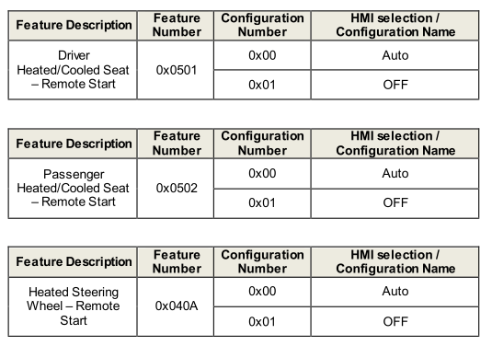

根据Vehicle Settings spec中要求：

设置方向盘加热和座椅空调为Auto时需发送如下消息

Operation = set

1. Driver Heated/Cooled Seat (0x0501) = Auto
2. Passenger Heated/Cooled Seat (0x0502) = Auto
3. Heated Steering Wheel (0x040A) = Auto

三个feature配合使用才可设置成功。

设置方向盘加热和座椅空调为OFF时需发送如下消息

Operation = set

1. Driver Heated/Cooled Seat (0x0501) = OFF
2. Passenger Heated/Cooled Seat (0x0502) = OFF
3. Heated Steering Wheel (0x040A) = OFF

三个feature配合使用才可设置成功。

界面接收response消息时只根据Driver Heated/Cooled Seat (0x0501)的结果显示Auto还是OFF。Passenger Heated/Cooled Seat (0x0502)和Heated Steering Wheel (0x040A)的状态可忽略。

## 2.3 座椅空调

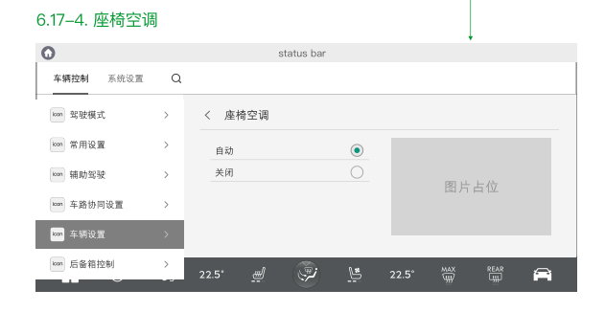

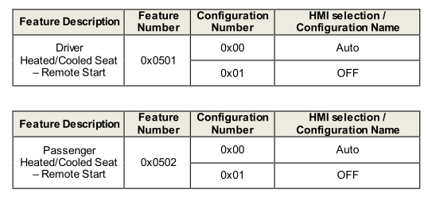

根据Vehicle Settings spec中要求：

设置座椅空调为Auto时需发送如下消息

Operation = set

1. Driver Heated/Cooled Seat (0x0501) = Auto
2. Passenger Heated/Cooled Seat (0x0502) = Auto

两个feature配合使用才可设置成功。

设置座椅空调为OFF时需发送如下消息

Operation = set

1. Driver Heated/Cooled Seat (0x0501) = OFF
2. Passenger Heated/Cooled Seat (0x0502) = OFF

两个feature配合使用才可设置成功。

## 2.4 周期

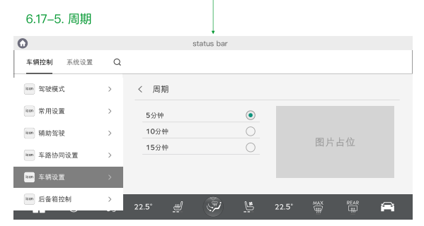

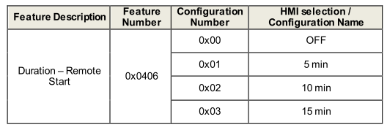

设置周期时需发送如下消息：

Operation = set

FeatureID = 0x0406

Configuration的设置范围 0x1 – 0x3

# 3 FBMP协议简介

遥控启动设置走CAN消息，遵循FBMP协议。

FBMP协议请求消息包含4条信息：

操作码Operation 对应信号：CtrStkDsplyOp_D_Rq

需求ID FeatureID 对应信号：CtrStkFeatNoActl

值 Configuration 对应信号：CtrStkFeatConfigActl

个性配置 PersIndex 对应信号：CtrStkPersIndex_D_Actl

|  |  |  |  |
| --- | --- | --- | --- |
| Name | Literals | Value | Description |
| Operation | - | - | 操作请求类型 |
|  | Null | 0x0 |  |
|  | Query | 0x1 |  |
|  | Set | 0x2 |  |
|  | Upload | 0x3 |  |
|  | Restore | 0x4 |  |
|  | Copy | 0x5 |  |
|  | NotUsed | 0x6-0x7 |  |
| FeatureID | - | - | 操作请求的需求ID |
|  |  | 0x0000-0xFFFF |  |
| Configuration | - | - | 操作请求的值 |
|  |  | 0x0000-0xFFFF |  |
| PersIndex | - | - | 指示操作访问哪个个性配置 |
|  | PERS_1 | 0x0 |  |
|  | PERS_2 | 0x1 |  |
|  | PERS_3 | 0x2 |  |
|  | PERS_4 | 0x3 |  |
|  | VEHICLE | 0x4 |  |
|  | Not Used | 0x5 |  |
|  | Not Used | 0x6 |  |
|  | Not Used | 0x7 |  |